Sykesville Civics Day 2025
Monday , 5/19/2025
5-8pm
Sykesville Town House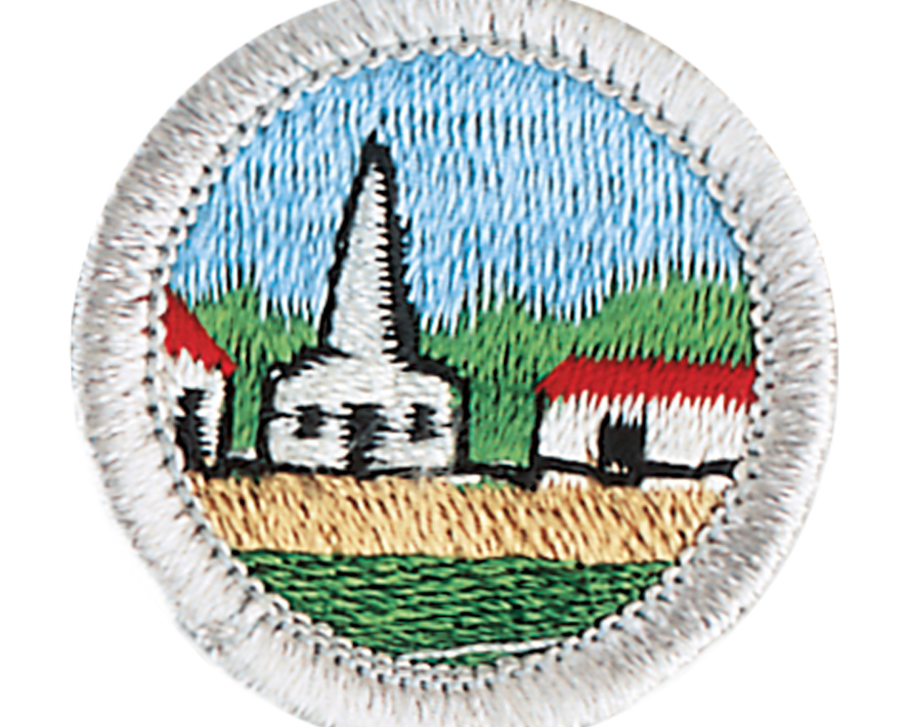
7547 Main Street, Sykesville, MD.
FREE
If you have any questions, email us at gatehouse@sykesville.net or call us at (410)549-5150

Citizenship in the Community badge
Updated to meet the new 2025 requirements
NOTE: this outline has been created based on the requirements found at https://www.scouting.org/merit-badges/citizenship-in-the-community/
A PDF (2023) of these requirements (organized slightly differently) produced by Scouting America can be found here: http://www.usscouts.org/mb/worksheets/Citizenship-in-the-Community.pdf

At the Gate House
1.What does “citizenship in the community” mean?
Citizenship: ________________________________________________________________________
Community: ________________________________________________________________________
Or: Demonstrated understanding verbally with Gate House Staff (initial)__________________
2. What does it take to be a good citizen in your community?
____________________________________________________________________________________
____________________________________________________________________________________
____________________________________________________________________________________
____________________________________________________________________________________
____________________________________________________________________________________
Or: Demonstrated understanding verbally with Gate House Staff (initial)__________________
3.Discuss the rights, duties, and obligations of citizenship,
Citizenship
Rights Duties Obligations

Or: Demonstrate by contributing to the poster version of this activity and snap a picture.

4. How can you demonstrate good citizenship in your scouting unit, place of worship or school (pick one)?
____________________________________________________________________________________
____________________________________________________________________________________
____________________________________________________________________________________

5. When people pay local taxes, that money provides services to the community.
How do each of the following support the community?

Police/Public Safety

Parks

Public Works (solid waste and maintenance)

At Home:
6. Watch a recent meeting of our town Council or County Commissioners. You can find the Sykesville town council meetings and other town government meetings here: https://www.youtube.com/@townofsykesville698
The schedule, agendas, and information about councilmembers can be found here: https://www.townofsykesville.org/2148/Mayor-Town-Council
1. Choose one of the issues discussed at the meeting where a difference of opinions was expressed.
Issue: _________________________________________________________________
2. Explain why you agree with one opinion more than you do another one.
_____________________________________________________________________________
_____________________________________________________________________________
_____________________________________________________________________________
_____________________________________________________________________________
_____________________________________________________________________________
_____________________________________________________________________________
_____________________________________________________________________________
7. Choose an issue (it does not have to be from this meeting) that is important to the citizens of your community and find out which branch of local government is responsible for this issue.
Issue:________________________________________________________________
______________________________________________________________________
Branch of local government responsible: ________________________________

At Civics Day:
8. Think back to the video you watched before you came and the issue you highlighted. At the event, ask what is being done to address this issue and how kids like you can help or participate.
When you go home, share what you learned with your counselor/ scout master.
FAQ for Scoutmasters and Parents
What help will my scout receive at these events?
At the Gate House:
- “Citizenship”: people who are born in this country or who were born elsewhere and have been granted citizenship by the government
- “Community” : a group of people living in a particular area who share common characteristics, interests, activities, or purposes
- Location of public services within Sykesville including:
  - Town House (our Town Hall)
  - Public Works
  - Sykesville Police Station
  - Nearby parks and recreation
    - Millard Cooper (where Movies in the Park and most events take place)
    - Carrie Dorsey Park
    - Linear Trail
    - Gate House Museum (Town-operated museum)
    - Visitors Post Office (town-operated as both recreational assistance and as a point of business)
- Videos related to understanding Sykesville’s specific government and elections
- Organization Chart of Town Government (also available at end of document here) to -discuss branches and what they do
-look at who is elected and who is appointed

At Civics Day:
Mayor and Council Members will be available to answer questions and to speak to about ideas.

At Home:
To complete this badge, you will need to do the following:
- Use a digital device to locate:
  - The Carroll County Courthouse (Westminster)
  - The nearest hospital, police station, and fire station to your house
(CONTINUES ON NEXT PAGE)
- Watch a movie that shows how the actions of one individual or group of individuals can have a positive effect on a community. Think about how this film showed a way to be a “valuable and concerned member of the community” (you will share this later with your scouting unit)
Find a list of 17 suggested films here: movies-for-citizenship-in-the-community
- Identify three charitable organizations outside of scouting that interest you and bring people in your community together to work for the good of your community.
a. Pick ONE of the organizations you chose for requirement
b. Using a variety of resources (including newspapers, fliers and other
literature, the Internet, volunteers, and employees of the organization), find out more about this organization.
c. With your counselor’s and your parent’s approval, contact the
organization you chose and find out what young people can do to help.
d. While working on this merit badge, volunteer at least eight hours of your time for the organization. After your volunteer experience is over, discuss what you have learned with your counselor.
- Develop a public presentation (such as a video, slide show, speech, digital presentation, or photo exhibit) about important and unique aspects of your community. Include:
  - information about the history, cultures, and ethnic groups of your community
  - its best features and popular places where people gather
  - the challenges it faces
Stage your presentation in front of your merit badge counselor or a group, such as your patrol or a class at school.

With Your Scouting Unit:
-Share with your scouting unit what you learned and talked about working on this badge including:
1. Talk about your interaction with an elected Town official on Civics Day.
2. Describe the film you watched, and talk about how it showed a way to be a “valuable and concerned member of the community.”
3. Discuss your volunteer experience related to this badge.
4. Share your presentation on local government.

